PAPER 2005-101
PETROLEUM SOCIETY
CANADIAN INSTITUTE OF MINING, METALLURGY & PETROLEUM

Global Resource Uncertainty Using a Spatial/Multivariate Decomposition Approach
W. Ren
University of Alberta
O. LEUANGTHONG
University of Alberta
C.V. Deutsch
University of Alberta

This paper is to be presented at the Petroleum Society’s 6th Canadian International Petroleum Conference (56th Annual Technical Meeting), Calgary, Alberta, Canada, June 7 – 9, 2005. Discussion of this paper is invited and may be presented at the meeting if filed in writing with the technical program chairman prior to the conclusion of the meeting. This paper and any discussion filed will be considered for publication in Petroleum Society journals. Publication rights are reserved. This is a pre-print and subject to correction.

Abstract
Uncertainty in petroleum resources is important for development planning and decision making. Increasingly, geostatistical techniques are used to integrate diverse data sources and provide a defensible model of uncertainty. Petroleum resources are calculated from a combination of variables including thickness, porosity, and saturation. Uncertainty in the global petroleum resources are calculated stepwise: (1) establish the local uncertainty in each variable using a conventional Gaussian geostatistical model, (2) sample the local distributions with spatial correlation using a p-field based technique, (3) modify the p-field samples to have the correct multivariate variability using the LU technique, and (4) assemble the distribution of uncertainty over any volume using the joint spatial/multivariate realizations. The alternatives to this technique are a simplistic Monte Carlo simulation without spatial correlation or a more complex high resolution geostatistical model. Speed and mathematical consistency are the main advantages of the proposed technique. The theoretical basis of the spatial/multivariate decomposition approach will be developed with the assumptions and implementation details. A realistic case study will be presented showing the global uncertainty in oil in place over arbitrarily large areas.

Introduction
Geostatistical techniques have been increasingly used for reservoir characterization for two main reasons: (1) different data sources can be integrated to predict a reservoir property between wells, and (2) an assessment of uncertainty in the estimation can be obtained.
Global uncertainty in petroleum resources is important for reservoir development planning and decision making. There are two challenges that must be addressed: (1) the scale of uncertainty – local uncertainty must be scaled to global uncertainty, and (2) the multivariate relationship between the variables that go into resource calculations – predictions of uncertainty must account for the correlation between variables.
Conventional geostatistical techniques predict local uncertainty at the scale of the data. Global uncertainty refers to the petroleum resource, or the oil in place (OIP), for an arbitrarily large area. The global uncertainty in OIP can not be calculated by simply summing the local uncertainties. The spatial continuity of the variables must be considered in scaling local uncertainty to global uncertainty. If the variable is very discontinuous, then the uncertainty decreases quickly with scale. If the variable is continuous, then the uncertainty decreases slowly, but fewer data are needed to constrain the uncertainty. Simulation must be used to combine uncertainty reconciling these two notions.
OIP is calculated from several reservoir properties, such as net pay thickness, porosity and oil saturation. Treating the variables independently has a risk of underestimating the global resource uncertainty. High values average out with low values. The correlation between the multiple constituent variables of OIP must be calculated.
A spatial/multivariate decomposition approach is proposed for assessing the global uncertainty in OIP from local uncertainties. The joint spatial and multivariate correlations are taken into account. The key idea is to simulate a set of spatially correlated probability values (a “P-field”) and then simultaneously draw the variable of interest at multiple locations. The local uncertainty (LU) decomposition is used to account for the multivariate correlations at each location. The resulting sets of multiple variables can be used to assess uncertainty over arbitrarily large volumes.
A detailed methodology of obtaining the local uncertainty and global uncertainty is provided. An example from a realistic case study is also included to show the calculation of the global uncertainty in OIP over arbitrarily larger areas.

Local Uncertainty Assessment
Various sources and types of data are available for reservoir modeling, including core data, well log data, seismic data, well test data, historical production data and conceptual geological models. These data all carry some information about the reservoir including properties such as porosity, permeability and saturation. Integrating these different data into a reservoir model is commonly achieved by geostatistics.
There are several geostatistical techniques that can be used to integrate different data into a geostatistical model, including Gaussian-based Bayesian updating, indicator cokriging, full cokriging and direct kriging. This paper focuses on the Bayesian updating approach due to its reliability and simplicity in data integration, and powerful mapping ability that reveals the contribution of the primary and secondary information on the updated results. In this method, directly measured well data including core and well log data are considered as primary data. The seismic data, trends and structural information, geological interpretations and other indirectly measured data are used as secondary data. The Bayesian updating method is a Gaussian-based technique, so all of the data must be transformed into normal scores prior to application.
In the Bayesian context, kriging well data provides a prior model for a reservoir property. Kriging uses well data to interpolate between the well locations. The closeness and redundancy of the well data are accounted for by the kriging weights that are used to calculate the resulting estimate and associated variance. Under the Gaussian paradigm, the local distribution is fully defined by these two parameters. The mapping of these estimates, therefore, only shows the primary information from the well data.
All secondary data can be mathematically combined based on their correlations to provide a likelihood model. Similar to the prior model, this model also consists of an estimate and variance, forming local distributions of uncertainty that yield a measure of the secondary data information content. The mapping of the likelihood estimates shows only the secondary information from the combination of secondary data.
Merging the primary information and the secondary information via Bayesian updating provides a posterior model for the reservoir property in the same Bayesian context. This model gives a best estimate (in the context of minimum uncertainty) based on the primary well data and the secondary data. The distribution of uncertainty is defined at each location in the form of a nonstandard normal distribution given by the updated mean and variance.
The updated distributions must be back transformed to real units to show the best estimate and uncertainty at each location in the units of the variable. It is common to summarize the uncertainty by way of the P10, P50 and P90 values (Figure 1). The P10 values provide a conservative estimate since there is a 90% probability of being larger than this value. Therefore, the map of P10 values can be used to identify the “surely high” regions where the P10 values are high. The P50 values correspond to the median estimate of the reservoir parameter at each location, and provide a measure of central tendency. The P90 values provide an optimistic estimate as there is a 90% probability of being less than this value. The map of P90 values can be used to identify the “surely low” areas where the P90 values are low.

Global Uncertainty from Local Uncertainty
The global uncertainty in OIP can not be directly calculated from the local uncertainties. Simulation must be performed to assess the global uncertainty. At each location, we have multiple constituent variables for calculating OIP, and each variable has a distribution of uncertainty. Randomly drawing a value from each distribution and then using them to calculate the resource implicitly assumes independence between the variables that is unrealistic. Since these variables are correlated in a statistical sense, we need to account for the multivariate correlations between these drawn values. This is further complicated by the fact that, for each variable, the values from multiple locations are related up to some distance, thus drawn values must also account for this spatial correlation.
A full co-simulation approach can be used to assess the global uncertainty. However, this approach is cumbersome to implement because of the complicated cross-variograms calculation and expensive computing time.
A spatial/multivariate decomposition approach is proposed for assessing the global uncertainty from local uncertainty. This approach is based on the P-field simulation technique and combined with LU decomposition. The “spatial/multivariate” term is used to identify that the simulated results of the multiple variables will be spatially correlated and statistically correlated.

Theory of the Proposed Approach
There are two techniques being used here: (1) LU simulation to account for the multiple variables, and (2) p-field simulation to account for the spatial correlation. The p-field simulation consists of three steps:
- Establish the local conditional distribution of the modeled variables.
(2) Generate a P-field, which is a set of probability values uniformly distributed between 0 and 1:
where u is a location in the field A, P(u) is the probability variable at the location u. These probabilities are correlated in space.
(3) Obtain a simulated value by sampling the local conditional distribution of uncertainty using the probability value, p(u) at the same location. The simulated value is
where the F⁻¹ is the inverse of the cumulative local conditional probability distribution.

An alternative implementation of P-field simulation is to draw a set of standard normal deviates, w(u) within the field A, and then restandardize these drawn values with the mean and variance of the local conditional distributions. These values could then be back transformed to the original units of the variable.
The P-field technique is used to simulate a single variable. We can use this technique to get spatially correlated values. To consider multiple variables and their correlations, LU decomposition can be used. This approach also requires the variables to be Gaussian.
Suppose that OIP is a function of n variables. The spatial/multivariate decomposition simulation for global uncertainty assessment from local uncertainty consists of the following steps:

- Build the local conditional distributions with the updated mean and variance for each variable.
- Generate a set of normal deviates for each variable.
where u is a location in the field A, and w_{i}(u) is the normal deviate for the i^{th} variable at location u.
- Determine the correlation matrix, ρ, for the n variables and perform Cholesky decomposition to get the lower and upper matrices, L and U respectively.
Note that for Cholesky decomposition, L is simply the transpose of U, that is L=U^{T}.
- Obtain the multivariate correlated normal deviates of n variables:
where Y_{L}(u) is the column matrix of the multivariate correlated normal deviates at location u. L is the lower global correlation matrix, and w(u) is the column matrix of the normal deviates from step (2).
- Obtain the simulated values using the following equation:
where σ and μ are the updated standard deviation, respectively, for the i^{th} variable..
- Back transform the simulated values to real units. And assemble the distribution of uncertainty over any volume using the joint spatial/multivariate realizations.

Most common geostatistical assumptions also apply to this approach. We assume that the data are representative, and the statistical properties of the data are the same over the entire modeled area. An assumption of multivariate Gaussianity is critical for this approach. Details of these assumptions can be seen in Deutsch and Zanon’s paper (2004).

Implementation of the Proposed Approach
A schematic illustration of the proposed work flow is shown in Figure 2. Virtually all of this work must be performed in Gaussian space; this requires that all the data (primary and secondary) must first be transformed into normal scores.
Step 1 of the methodology can be achieved by Bayesian updating to generate local distributions of uncertainty. Step 2 requires running unconditional simulations using sequential Gaussian simulation with the appropriate variograms. These variograms are calculated based on the normal scores of each data. Use of the variogram ensures that the set of normal deviates for each variable is spatially correlated. Step 3 is straightforward. Steps 4 and 5 can be implemented together; a GSLIB-compatible program was created to generate the spatial/multivariate correlated simulation values in Gaussian space. Finally, these simulated values are back transformed to original units. OIP can now be determined from the n simulated values at each location. Summing them up over any area of interest gives a simulated value of the global resource. With multiple realizations, we can assess the global uncertainty over the large area.

Example
This approach has been applied on real reservoirs; however, the results are considered highly confidential. This synthetic example was created to demonstrate the entire process from modeling local uncertainties to assessing global uncertainty.
In this example, we want to assess the global uncertainty in the OIP over a study area, which is about 4 sections (each section is 1 mi²): 3200m x 3200m. The OIP is calculated from the following equation:
where the A is the local area or model grid cell area, 20m x 20m, h is net pay thickness (NPT), and the φ and S_{o} are porosity and oil saturation, respectively. Assuming that φ S_{o} are measured together, we can consider them as one variable: production of porosity and oil saturation (PPS). Thus, the OIP is a function of two variables: NPT and PPS.
64 well data are available at a spacing of 400 m. The well locations and the histograms of NPT and PPS are shown in Figure 3. To assess the local uncertainties of the two variables, we also have three secondary variables available (Figure 4): three sequence boundaries (1 to 3) from seismic data and geological interpretation. The correlations between each primary variable and each secondary variable are shown in their cross plots (Figure 5), and summarized in the correlation matrix in Figure 6. The variograms of the two primary variables, NPT and PPS, are also shown in Figure 6.
The prior, likelihood and updated maps are shown in Figure 7. The prior maps only show the primary information from well data. The likelihood maps show the secondary information based on a combination of all secondary data. The updated maps show the combination of the primary and secondary information. After transforming the updated results back to real units, the P10, P50, P90 quantiles were plotted to show the uncertainties in NPT and PPS (Figure 8). An east-west cross-section for each quantile map was extracted and plotted together to show the uncertainty of net pay thickness in 1-D (Figure 9). The P10 values show the low side of the distribution; if it is high the NPT is most likely to be high. The P90 values show the high side of distribution; if it is low the NPT is most likely to be low.
Using the local uncertainties from the updated models, the spatial/multivariate decomposition simulation approach was used to generate 100 realizations. Realizations 5, 50 and 95 are arbitrarily chosen for illustration in Figure 10. In each realization, all values are spatially correlated over the model area. At each location, the two variables, NPT and PPS are statistically correlated and were used to calculate the OIP at that location (Figure 11). Two areas of interest and the whole model area were selected to assess the OIP (values are posted below the maps). Using the 100 realizations, we can assess the global uncertainties in OIP in these three areas (Figure 12). These distributions of global uncertainty look similar to a normal distribution. The global uncertainty in area 1 shows a mean of 38.41 million cubic meters and a standard deviation of 4.17. The global uncertainty in area 2 shows a mean of 40.93 million cubic meters and a standard deviation of 4.93. Area 1 is smaller than area 2, but the OIP mean and variance are very close. The global uncertainty in the whole model area shows a mean of 203.29 million cubic meters and a standard deviation of 10.23.

Conclusions
Bayesian updating method is simple and reliable for integrating diverse data and assessing local uncertainty. Assessing the global uncertainty in petroleum resource from local uncertainties requires consideration of the joint spatial/multivariate correlations. Adopting a p-field simulation approach in combination with LU decompositions permits us to account for these multi-layered correlations. This forms the spatial/multivariate decomposition simulation methodology that is a simple and practical alternative to full co-simulation.

Acknowledgement
The authors would like to thank the industrial sponsors of the Centre for Computational Geostatistics for financial support of this research: http://www.uofaweb.ualberta.ca/ccg/.

Nomenclature
n = number of variables used to calculate resource
μ = mean of a distribution
σ = standard deviation
w = normal deviates follow a standard normal distribution
ρ = correlation coefficient
y = normal score values
p = probability values
z = values in real unit
L = lower matrix
U = Upper matrix
Y = column matrix of correlated normal deviates
subscripts
S = simulated value
L = LU decomposition
i,j = data indicies
0 = oil

References
- Alabert, F.G., The practice of fast conditional simulations through the LU decomposition of the covariance matrix, Mathematical Geology, 19(5), p. 369-386, 1987
- DEUTSCH, CV, Geostatistical Reservoir Modeling, Oxford University Press, New York, 376 pages, 2002.
- DEUTSCH, CV and JOURNEL AG, GSLIB: Geostatistical Software Library and User’s Guide, Oxford University Press, New York, second edition, 376 pages, 1998.
- Deutsch, C.V. and Zanon, S., Direct Predication of Reservoir Performance with Bayesian Updating Under a Multivariate Gaussian Model. Paper presented at the Petroleum Society’s 5th Canadian International Petroleum Conference (55th Annual Technical Meeting), Calgary, Alberta, Canada, June 8 – 10, 2004.
- DOYEN, PM., DEN BOER, LD, PILLEY, WR, Seismic porosity mapping in the Ekofisk field using a new form of collocated cokriging. Society of Petroleum Engineers, SPE 36498, 1996.
- Srivastava, R. M., Reservoir characterization with probability field simulation: SPE Formation Evaluation, 7(4), p. 927–937, 1992.

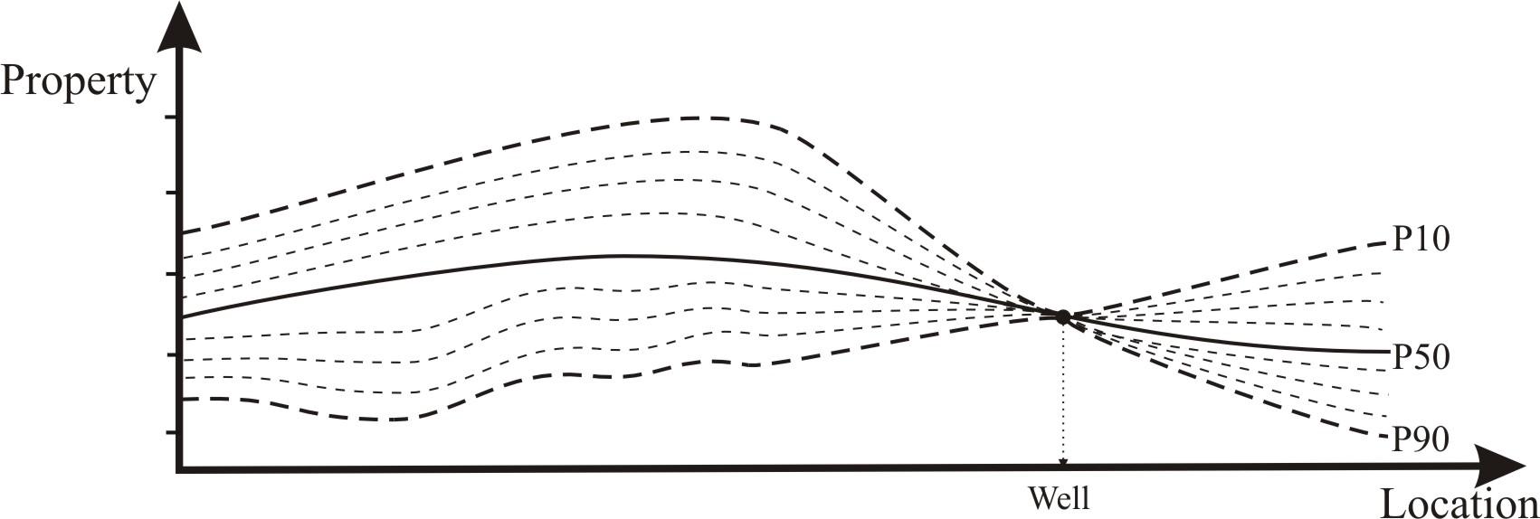

Figure 1: The local uncertainty is usually summarized by P10, P50 and P90 values. At the well location, the uncertainty is zero.

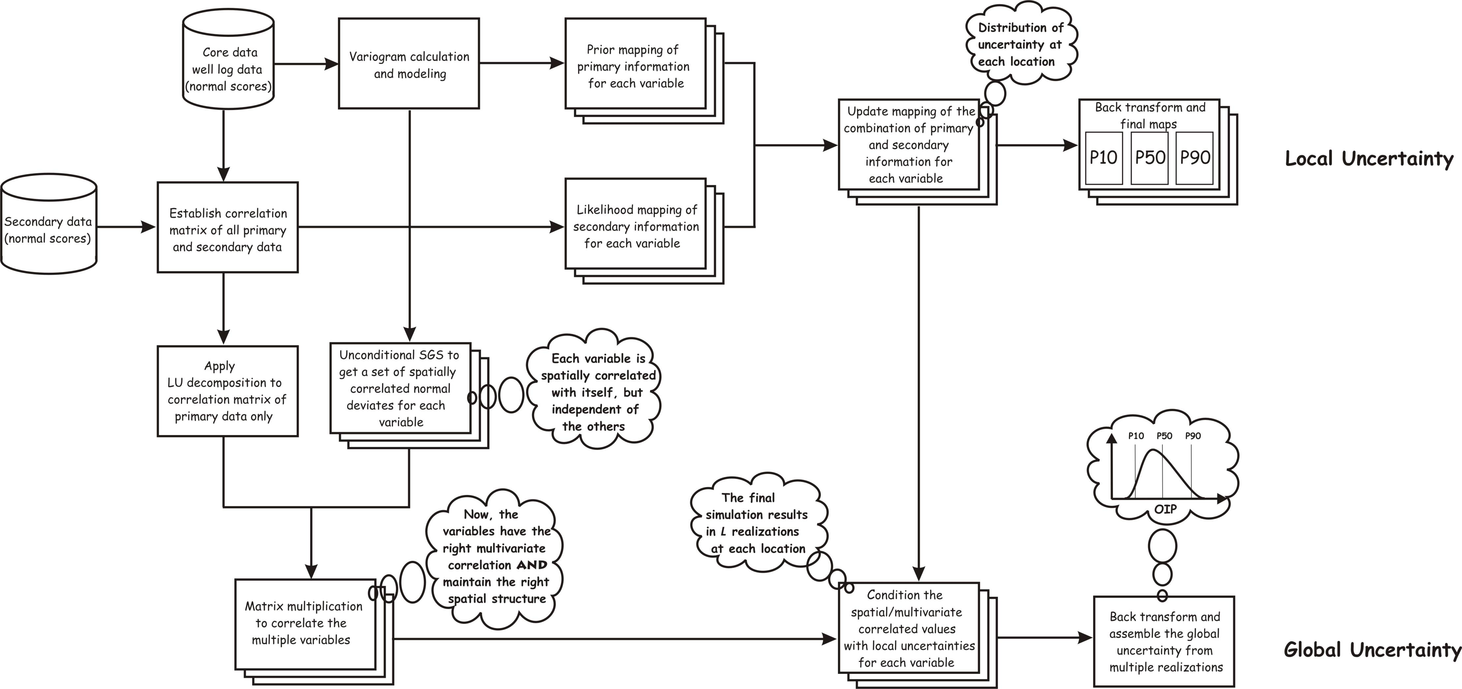

Figure 2: Work flow of the spatial/multivariate decomposition simulation approach for assessment of the global uncertainty from local uncertainty.
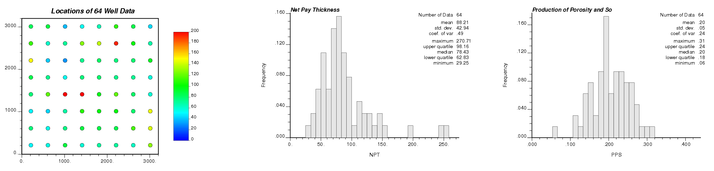
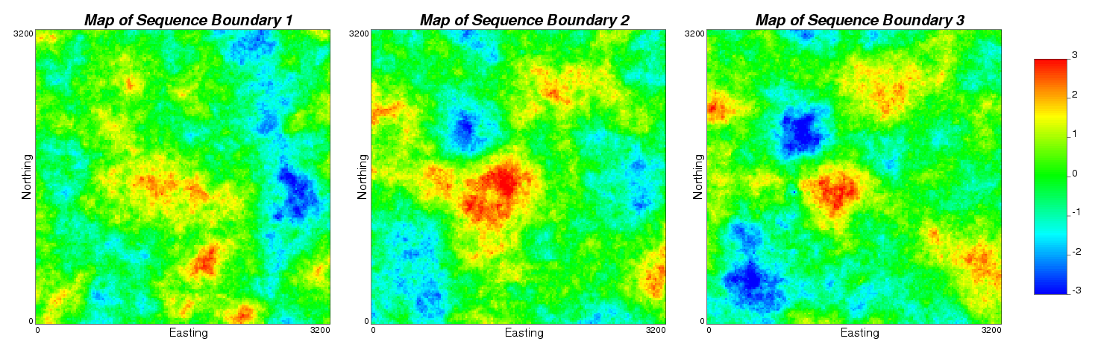
Figure 3: The location map of the 64 wells with the colour scale showing the net pay thickness (left), and histograms of net pay thickness (centre) and production of porosity and oil saturation (right).

Figure 4: Maps of three secondary variables: sequence boundary 1 (left), sequence boundary 2 (centre) and sequence boundary 3 (right).

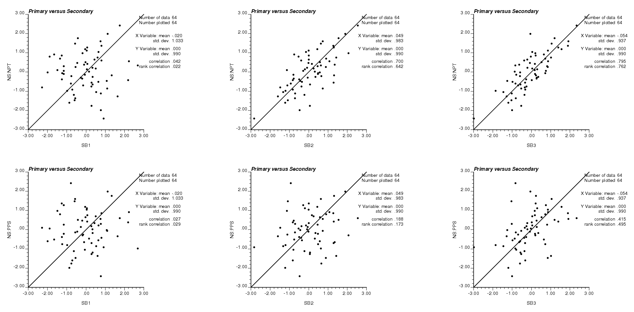
Figure 5: Cross plots of each primary data with secondary data. The net pay thickness is in the top row, and the production of porosity and So is in the bottom row. Three secondary data: sequence boundary 1 (left), sequence boundary 2 (centre) and sequence boundary 3 (right).

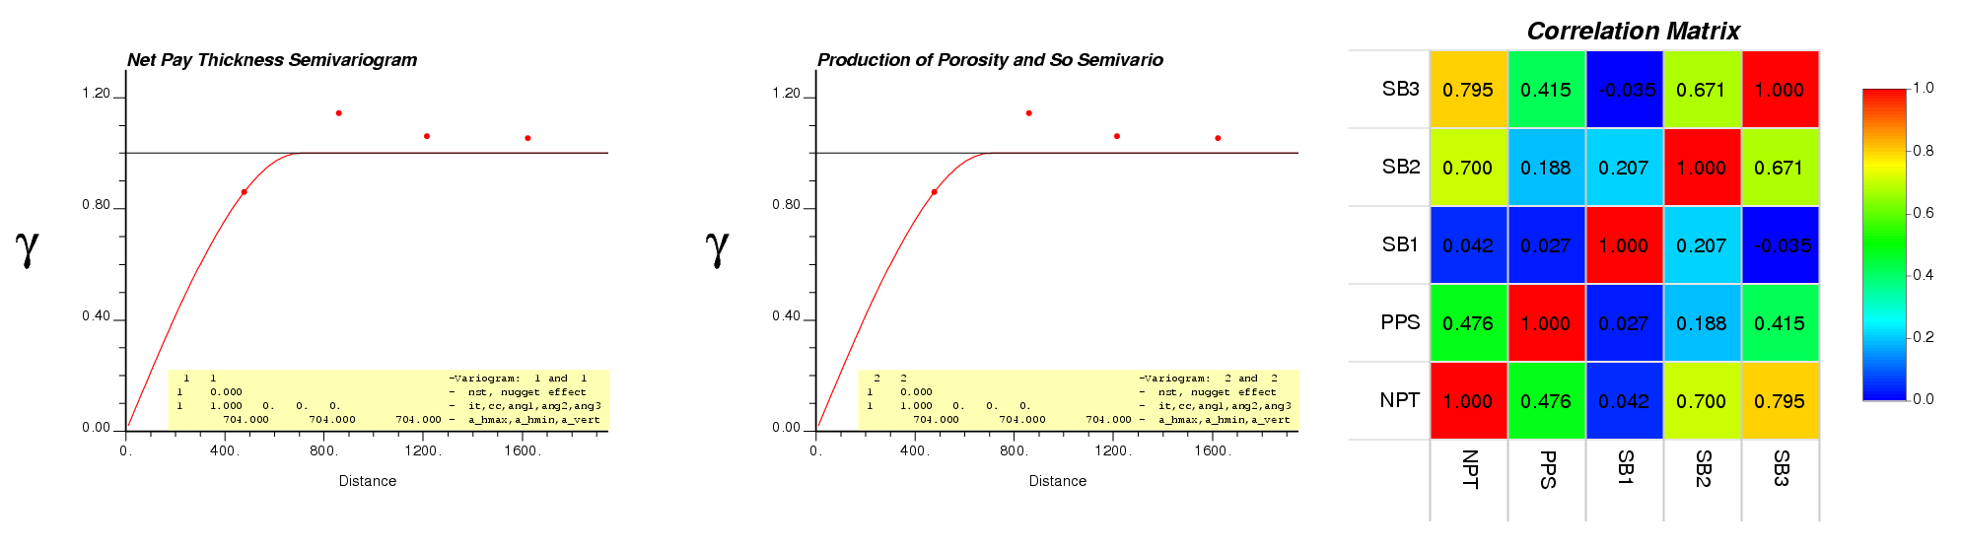
Figure 6: Variogram for two primary data (left and centre) and the correlation matrix between the primary and secondary variables (right).

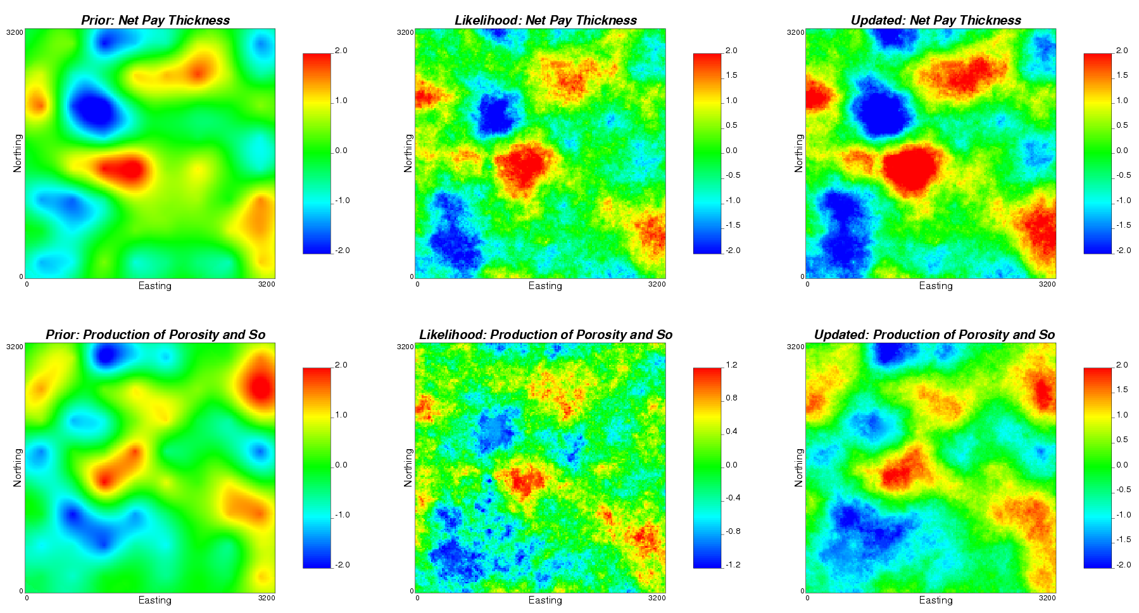
Figure 7: Prior (left), likelihood (centre) and updated (right) maps for net pay thickness (top) and production of porosity and So (bottom).
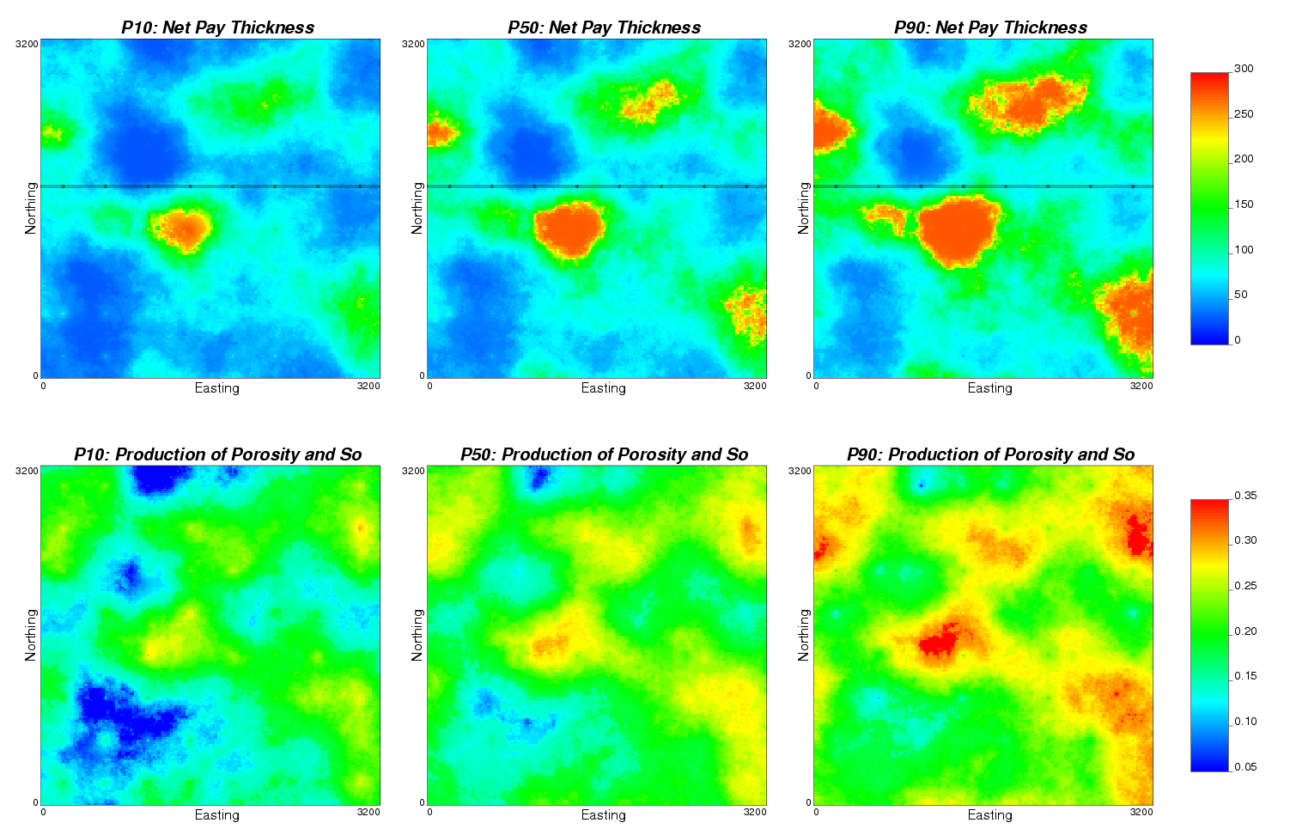
Figure 8: Final maps of uncertainty for net pay thickness (top row) and production of porosity and So (bottom row): P10 (left), P50 (centre) and P90 (right).Note the east-west section lines in the net pay thickness final maps is plotted in Figure 9, and the black circles represent well locations.
Figure 9: Uncertainty of net pay thickness in an east-west section: P10 (bottom line), P50 (middle line), and P90 (top line).

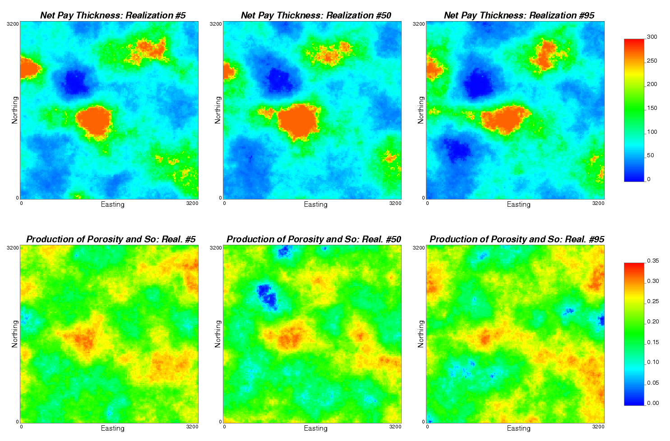
Figure 10: Realizations 5, 50 and 95 of the spatial/multivariate decomposition simulation results. In each realization, all values are spatially correlated over the model area and the net pay thickness (top) and the production of porosity and So (bottom) are also statistically correlated.
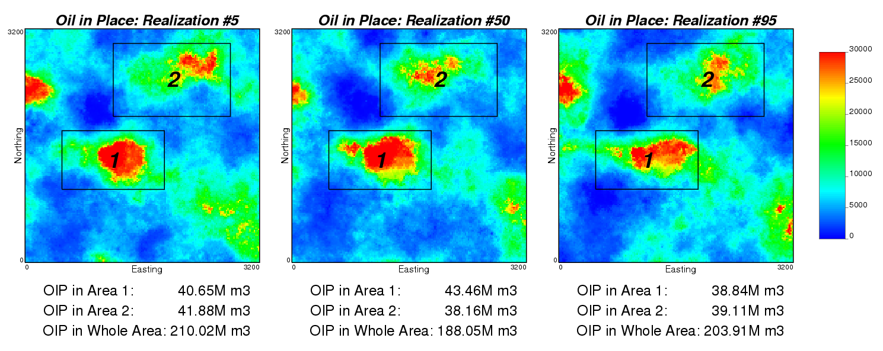
Figure 11: Calculated OIP from the two variables shown in Figure 10. Two areas of interest (in black line) and the whole model area were selected to estimate the OIP. The OIP in the three areas are shown below the maps for each realization.

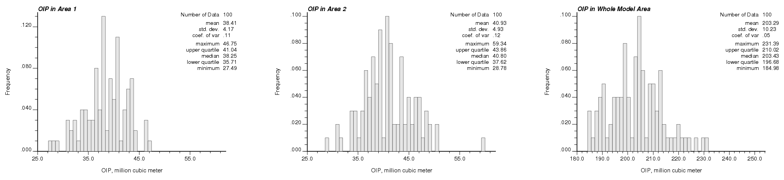
Figure 12: Distributions of global uncertainty in OIP in Area 1 (left), Area 2 (centre), and Whole Model Area (right).

